# File permissions in Linux

## Project description

In this example, my security team and operating out assist in cleaning up permissions in the R&D department. Below documents the steps taken in linux terminal to identify and fix issues.

## Check file and directory details

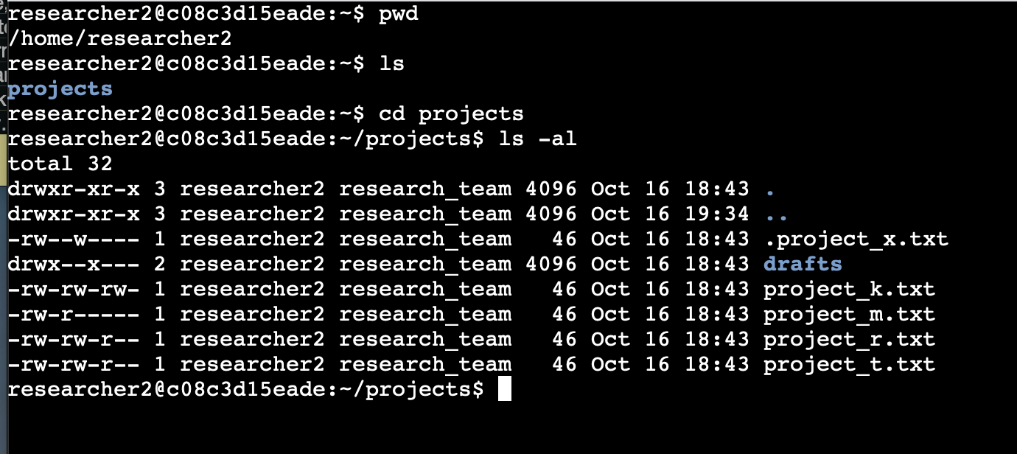

## Change file permissions

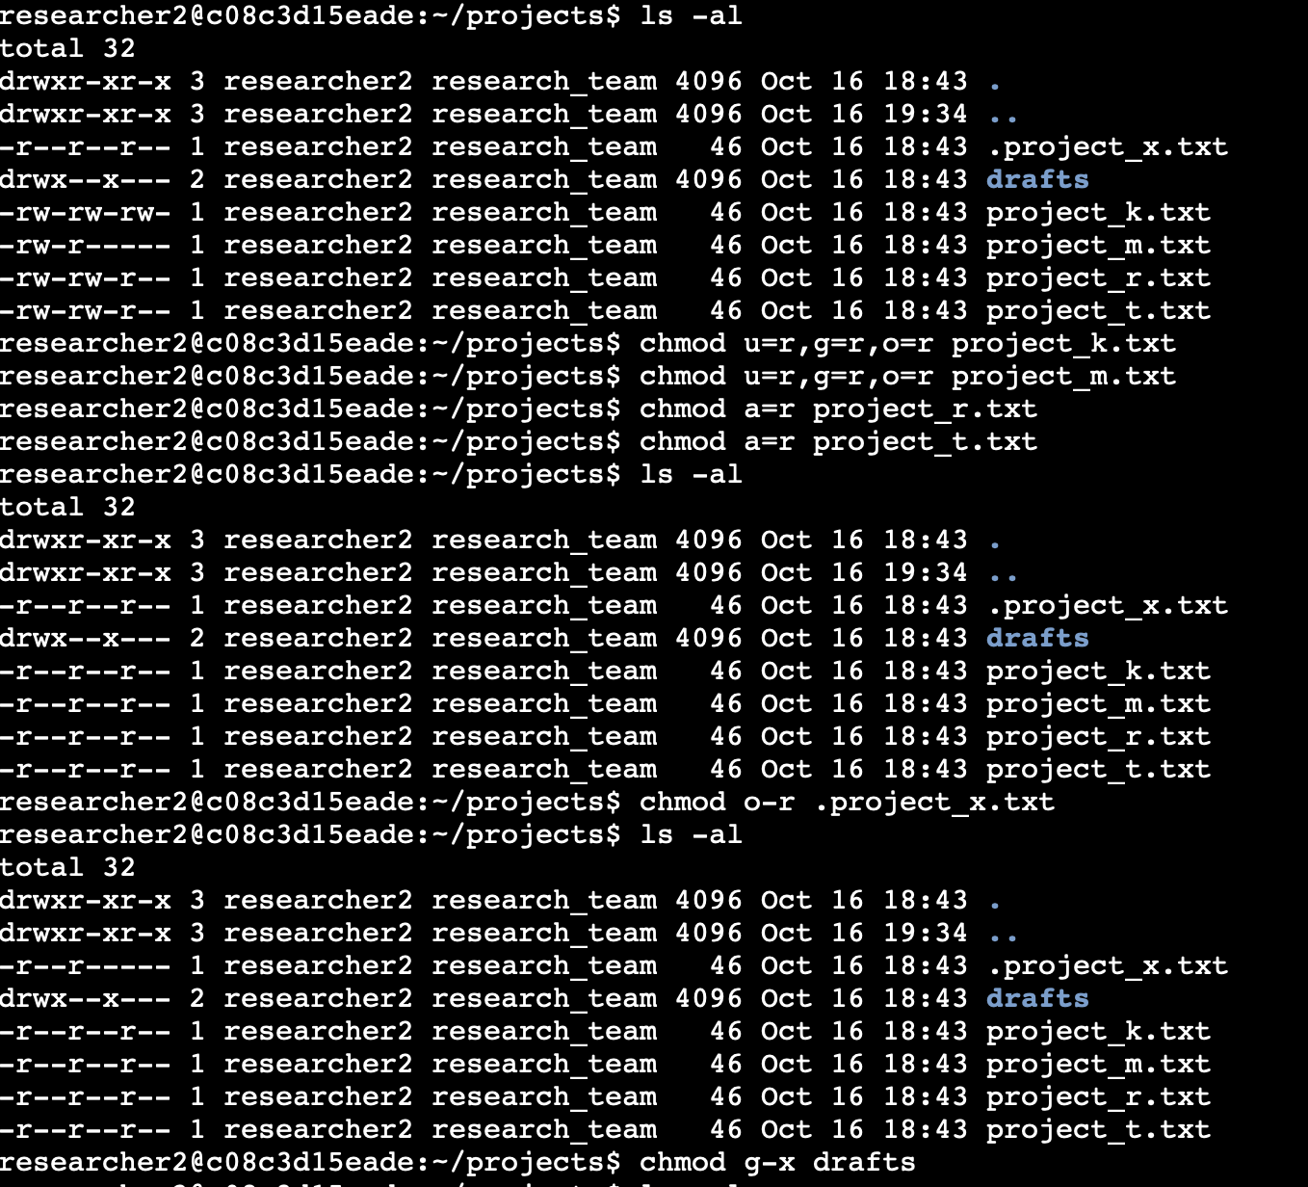

## Change directory permissions

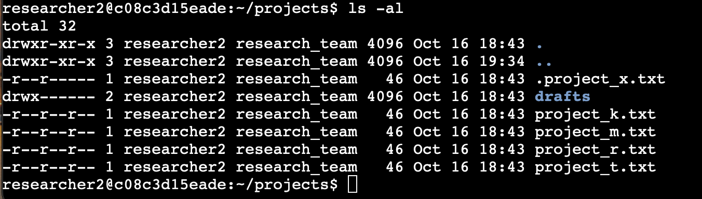

## Summary

As can be seen above, utilizing the chmod command I was able to access and modify multiple different files and the projects directory to align with company security clearance expectations. Utilizing the list command to show all hidden files and associated privileges I was able to inspect the symbolic permission string for each file in the projects folder. Within the chmod command I utilized the argument a=r to quickly modify all users to read permission on multiple files.